Building a Swarmie

Table of Contents

2 Introduction 1

3 Guide to 3D Printed Parts 2

4 Preparation – Drilling, Tapping, and Soldering 2

4.1 GPS/IMU Mount 2

4.2 NUC Base 2

4.3 Battery Base and Battery Brace 3

4.4 Ultrasound Tower 4

5 Chassis Assembly 4

5.1 Brackets 5

5.2 Motors 6

5.3 Tire Assembly 9

5.4 Bottom Plate 13

5.5 Wheel Attachment 17

6 Top Plate Assembly 19

6.1 3D Printed Parts 19

6.2 Ultrasound Sensor Mounting 20

6.3 NUC Base, Camera, IMU, GPS 22

6.4 PCB, Switch, and Bus Connections 23

6.5 NUC Assembly 23

6.6 Cover Plate Assembly and Attachment 23

7 Fully Assembled 23

# Introduction

[Place any notes or important information needed prior to assembly]

All metric screws are colored black.

All imperial screws are stainless steel.

# Guide to 3D Printed Parts

[Pictures with names of each part. I think this is important because some of the parts may be hard to identify.]

# Preparation – Drilling, Tapping, and Soldering

A few of the 3D printed parts have holes that need to be drilled and tapped. These holes sometimes are filled with wax, but you can drill it out easily. Tap lubricant should not be needed as the holes were all filled with wax at one point.

## GPS/IMU Mount

Use a #50 drill bit to drill out the hole shown in the picture below.

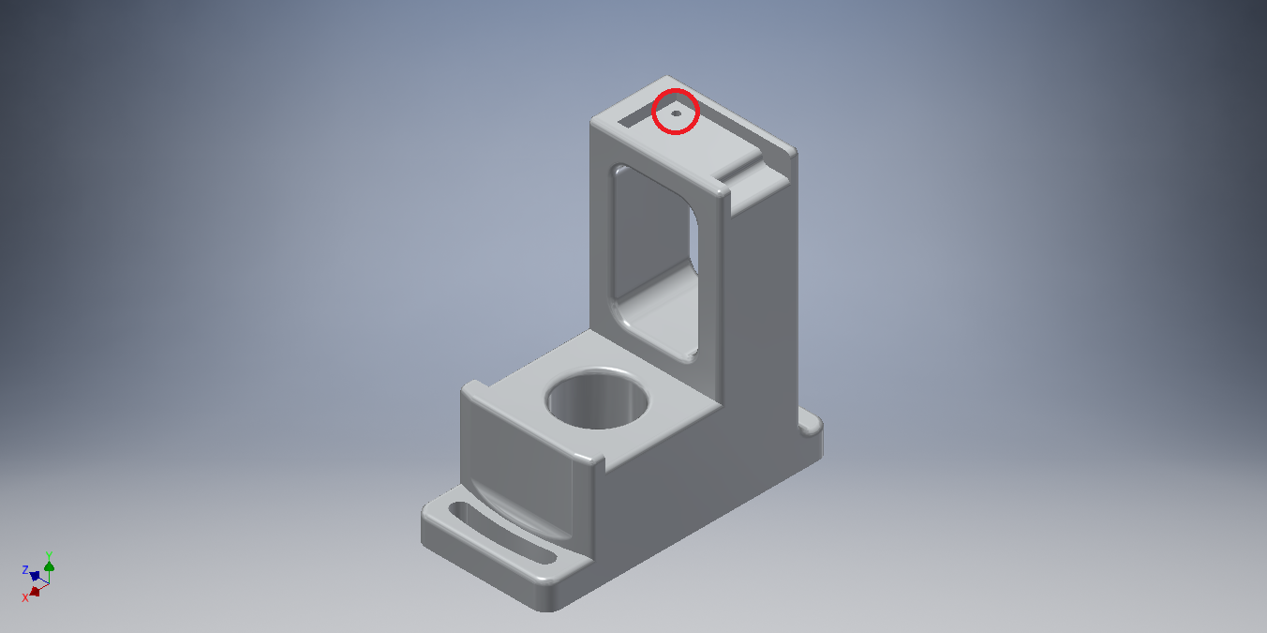

Use a 2-56 tap to tap the hole.

Note: this hole will be used for securing the IMU using a 2-56x1/2” nylon screw.

## NUC Base

Use a #50 drill bit to drill out the holes indicated in the picture below.

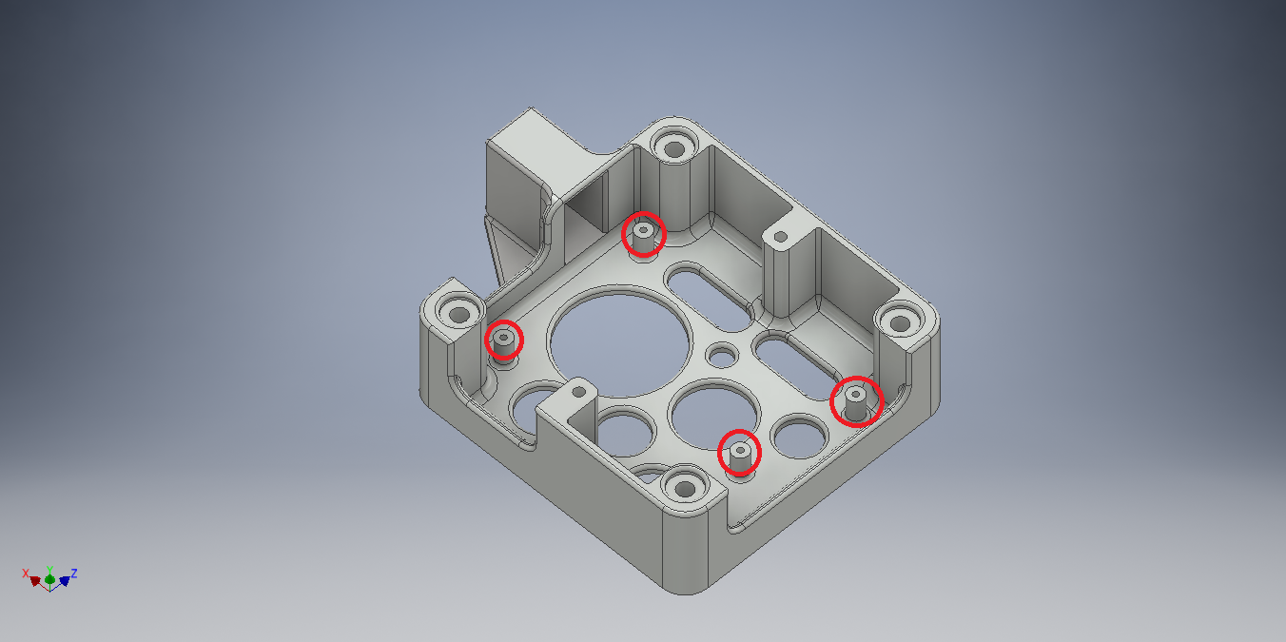Use a 2-56 tap to tap the holes.

## Battery Base and Battery Brace

Use a #43 drill bit to drill out the four holes indicated in the picture below.

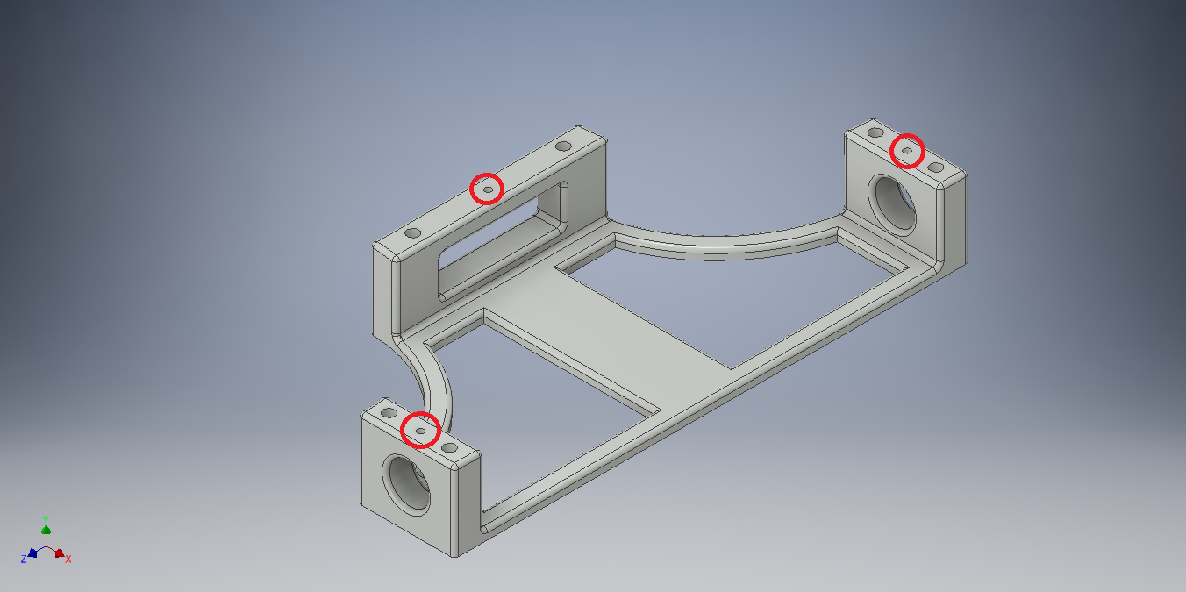

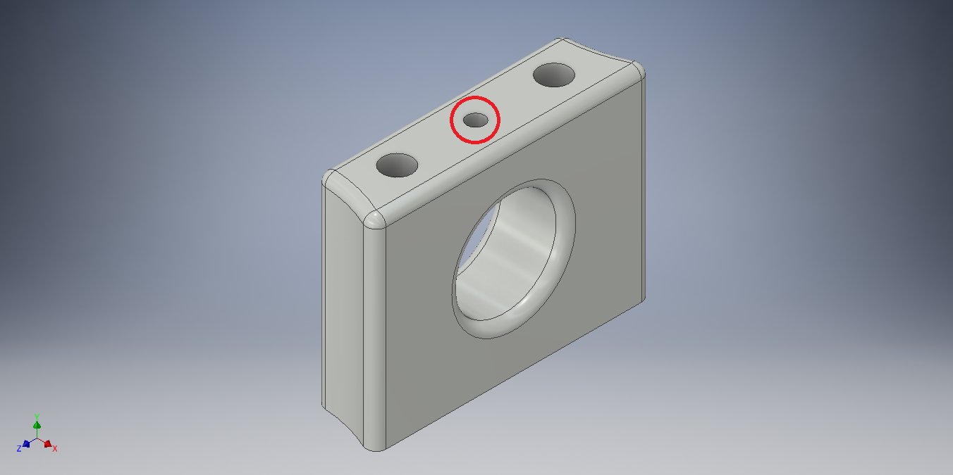

Use a 4-40 tap to tap the holes.

## Ultrasound Tower

Use a #43 drill bit to drill out the 10 holes indicated in the picture below. Warning: holes 1 and 2 are not through holes. You should be able see through the material to know how deep to drill.

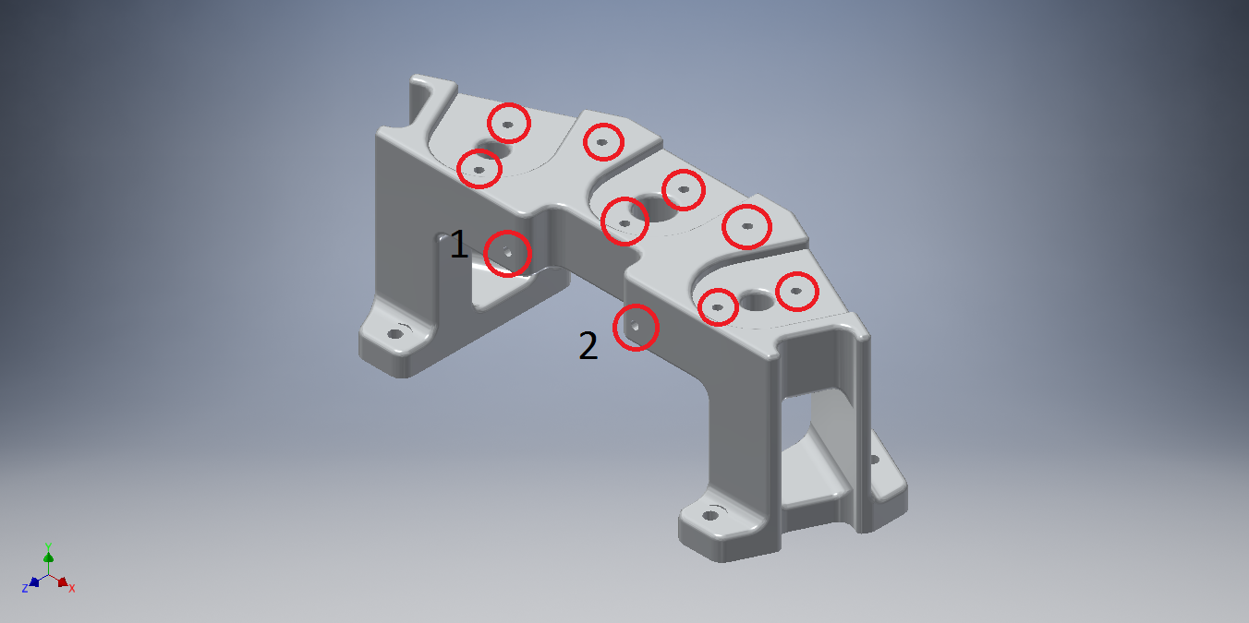Use a 4-40 tap to tap the holes. Note: because holes 1 and 2 are not through holes, you may need to partially tap them, remove and clean the tap, then finish tapping.

## Solder IMU Headers

# Chassis Assembly

[The below list needs to be updated or removed. I’m tempted to remove it and add lists for each subsection]

Tools:

* Phillips screw driver – M3x6mm screws
* 2mm hex key – M3x4mm screws
* 3/32” hex key – 4-40x1.5” screws
* ¼” nut driver – 4-40 nyloc nuts

Parts:

* 12x M3x6mm screws – packaged with the chassis kit.
* 8x M3x4mm screws
* 8x 4-40x1.5” screws
* 2x pairs of black brackets – packaged with the chassis kit.
* 4x DC motors
* Laser cut bottom plate
* Battery
* Fire retardant bag
* 3D printed battery base
* 3D printed battery brace
* 3D printed battery cross strap
* 2x wheel mounting hub kits – comes with 2 hubs each.

## Brackets

Using eight M3x6mm screws, attach all four brackets together as seen below.

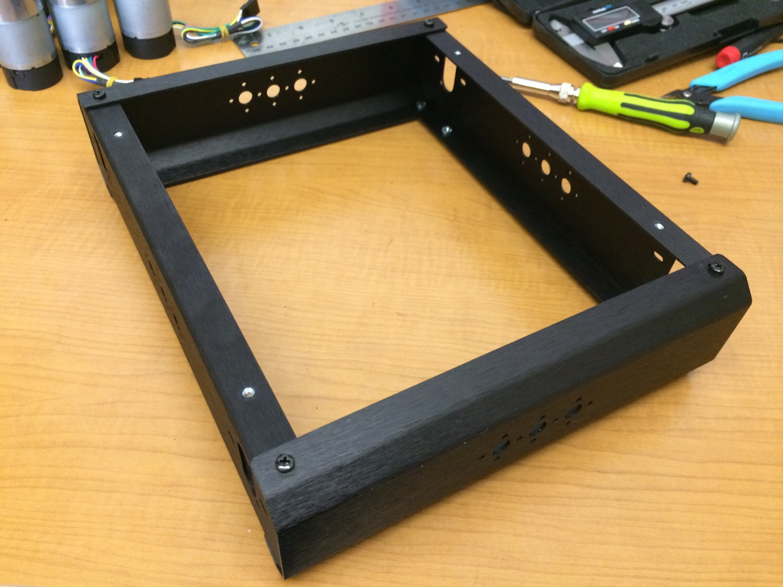

Figure 1: Chassis brackets fully attached

## Motors

Attach motors to mounting holes using two M3x4mm screws per motor. The motor shaft should be towards the bottom of the chassis. See below for detail.

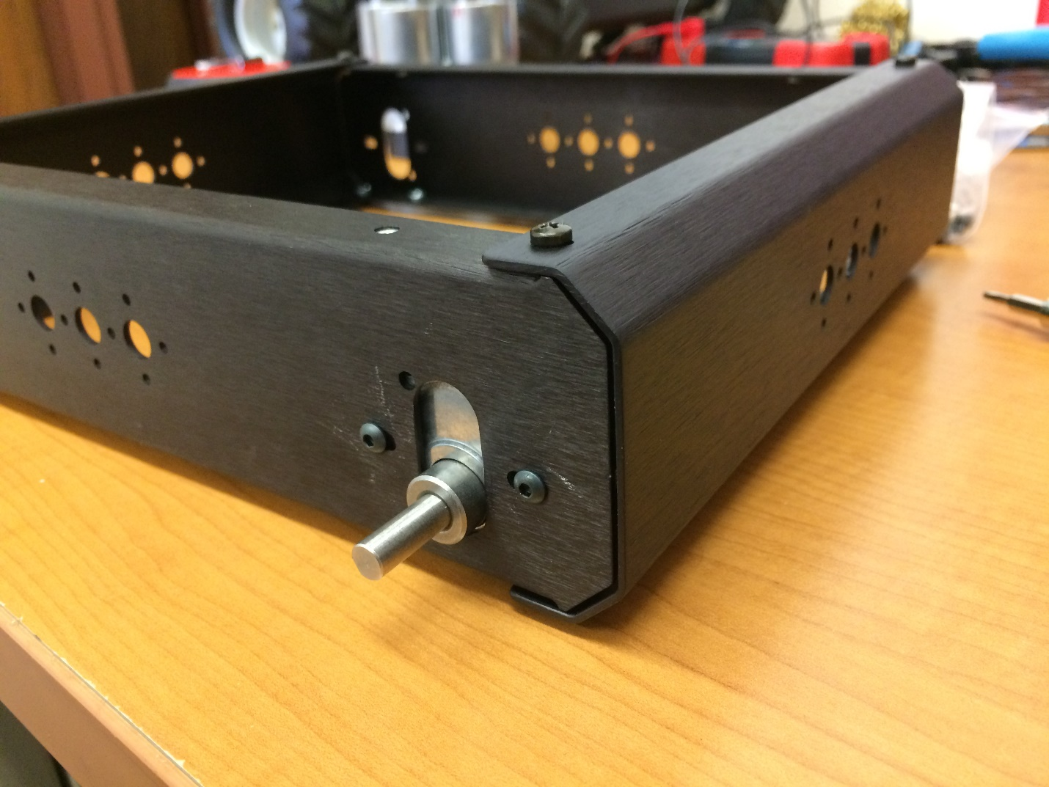

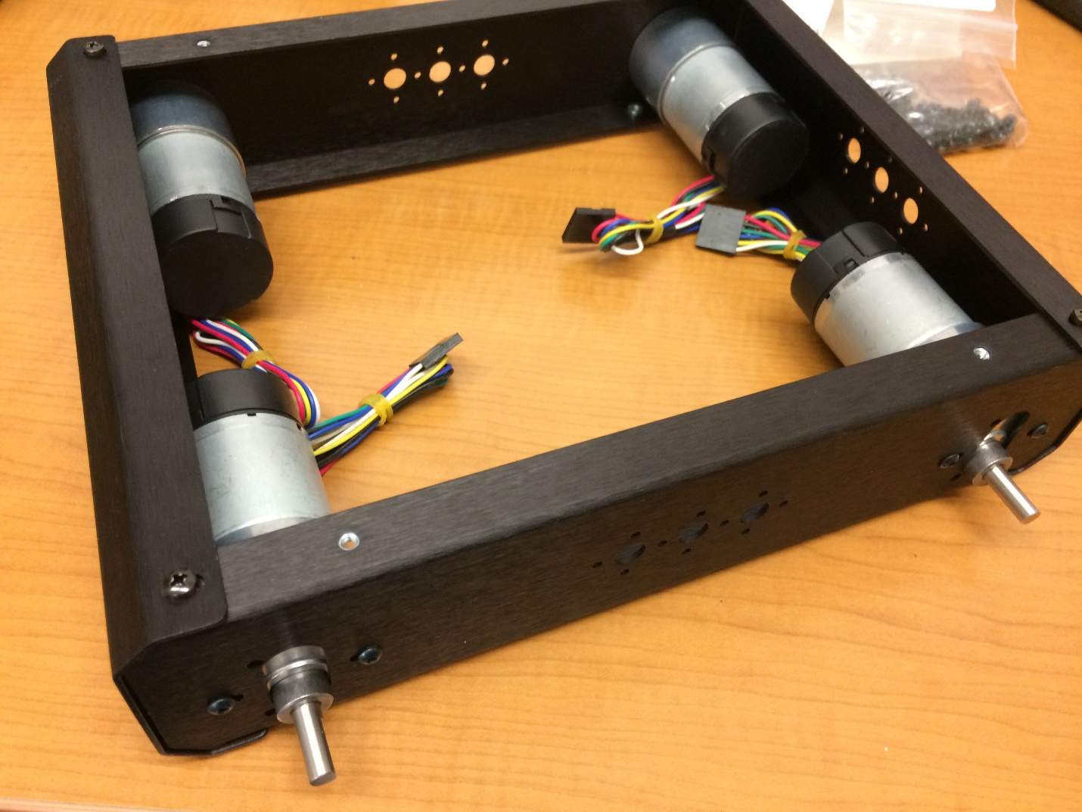

## Tire Assembly

Wheel assembly instructions have been adapted from Lynxmotion’s instructions found here: <http://www.lynxmotion.com/images/html/build007.htm>

1. 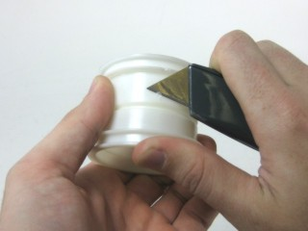First use a utility knife, or similar, to carefully remove any imperfections on the inner part of the rim. This will make things much easier later on.
2. Pull one side of the tire out, so that it protrudes, like in the image. Insert one side of the rim. It helps to insert at an angle in the middle, where the opening is the largest. Rotate the rim slowly, while pressing it in, to help coax it into place.

Figure 2

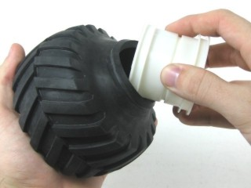

Figure 3

1. 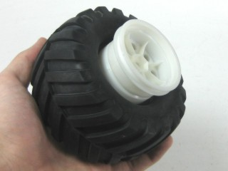You should end up with the tire and rim looking like Figure 4.

Figure 4

1. Pull out the side of the tire again, so that it looks like Figure 5.

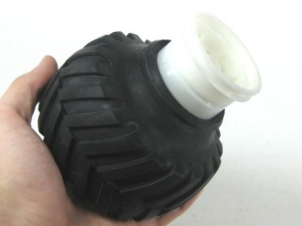

Figure 5

1. 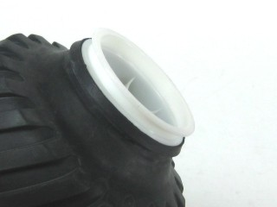Gently press and rotate the rim into the tire. You want to end up with the rim almost fully into the tire with the bead still sticking out, as in Figure 6. If there are any imperfections leftover from Step 1, then it may be difficult to pass the tire over them.

Figure 6

1. Quickly press the rim into the tire from both sides. The bead should now be completely in the flange. This step may require several attempts.

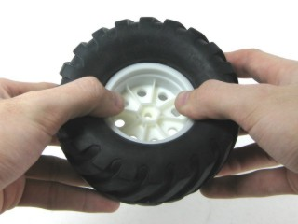

Figure 7

1. 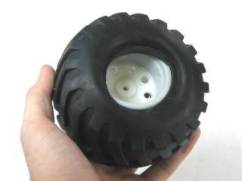Flip the tire over. It should look something like Figure 8.

Figure 8

1. Almost half the bead is in the flange. Just hold that side in and pull the rest of the bead away from the center, and it will retract back into the flange. It may be helpful to use a screw driver to pull the tire over the wheel.

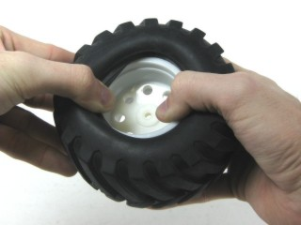

Figure 9

1. 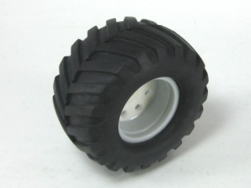A completed tire is shown in Figure 10.

Figure 10

## Bottom Plate

Tools:

* 1/16” hex key – 4-40x1/2” screws
* 3/32” hex key – 4-40x1.5” screws
* ¼” nut driver – 4-40 nyloc nuts

Parts:

* 8x 4-40x1.5” screws
* 4x 4-40x1/2” screws
* 4x M3x6mm
* 16x washers
* Battery Base
* Battery Brace
* Battery Cross Strap
* Battery
* Fire retardant bag

Using 8 4-40x1.5” screws and nyloc nuts, attach the battery base and battery brace. The battery brace is flatter on one of the sides with screw holes, this is the bottom. Use washers on both sides of the screws.

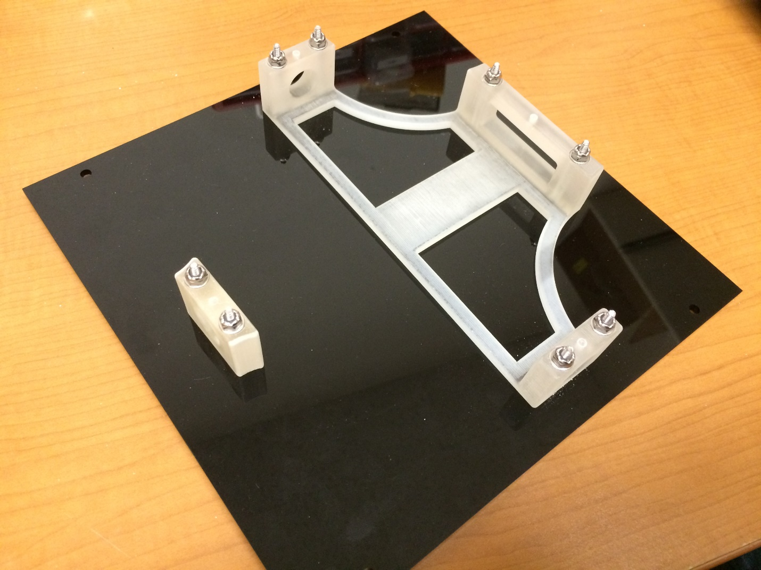

Using 4 M3x6mm screws, attach the bottom plate to the bottom of the chassis. You will notice that the motor shafts are closer to one side of the chassis, this side is the bottom. The plate can be attached in orientation that it fits, the orientation will matter when the wheels are attached.

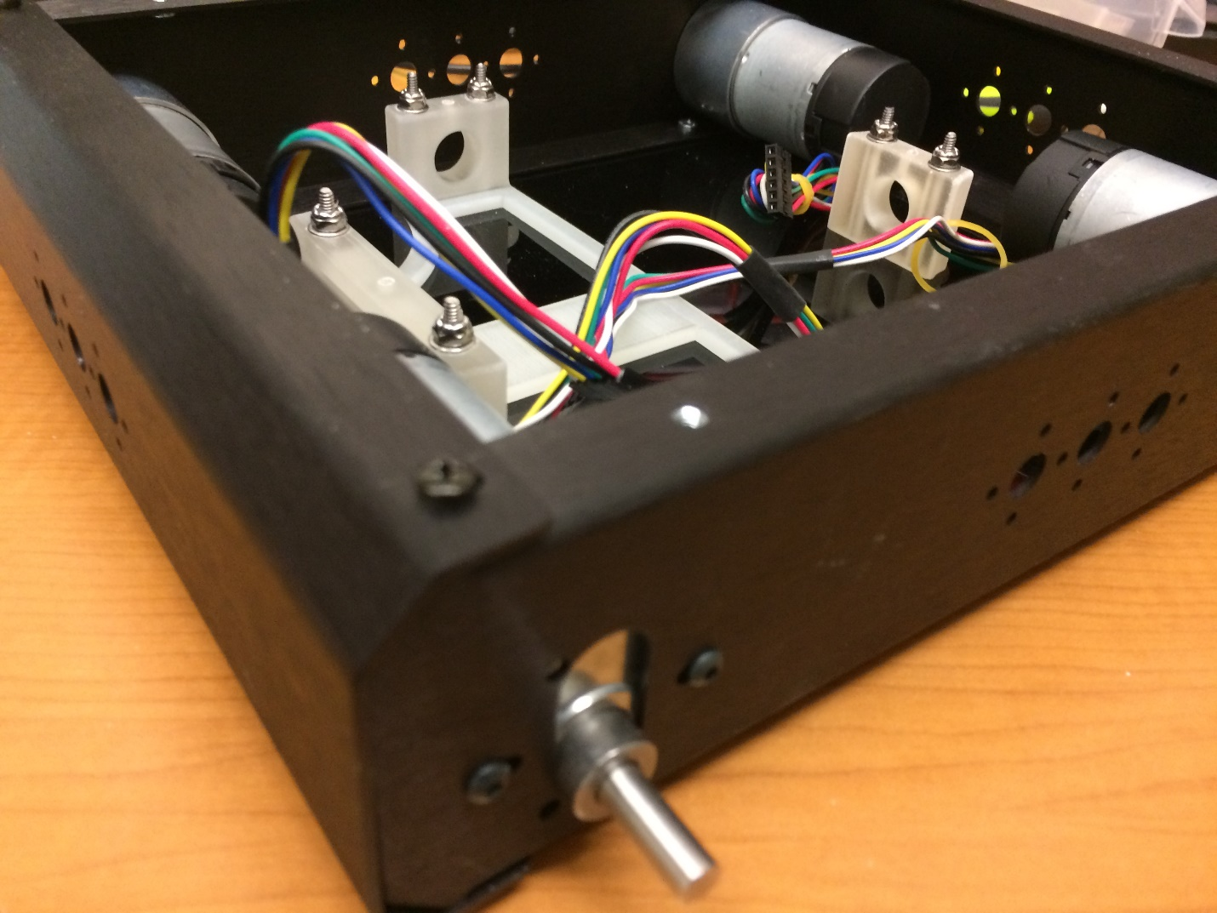

Insert the battery into the fire retardant bag in the following way. With the bag’s warning facing you, insert the battery with the wire leads coming out on the right. Close the Velcro flap and wrap it around the back of the bag as tightly as possible. This is necessary to properly fit into the battery base.

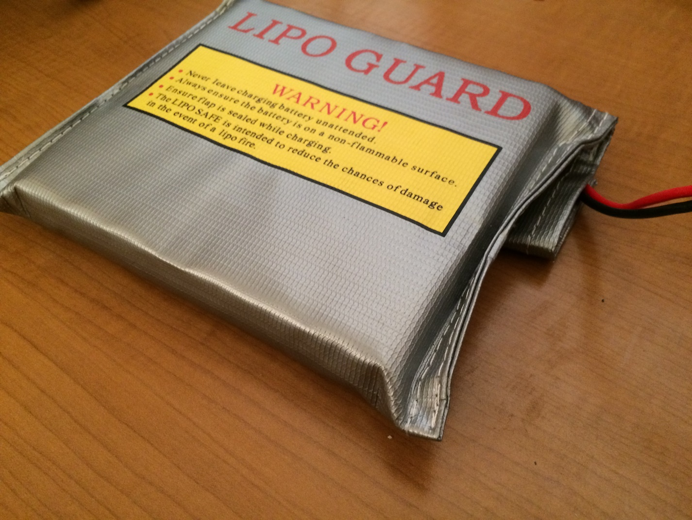

Carefully lay the battery into the chassis to keep the bag tight. The flap of the battery should be against the black acrylic of the bottom plate. Next, use 4x 4-40x1/2” screws (button head) to screw the battery cross strap to the battery base and battery brace. This strap fits only one way, line up the holes and be sure that the flat side is against the battery.

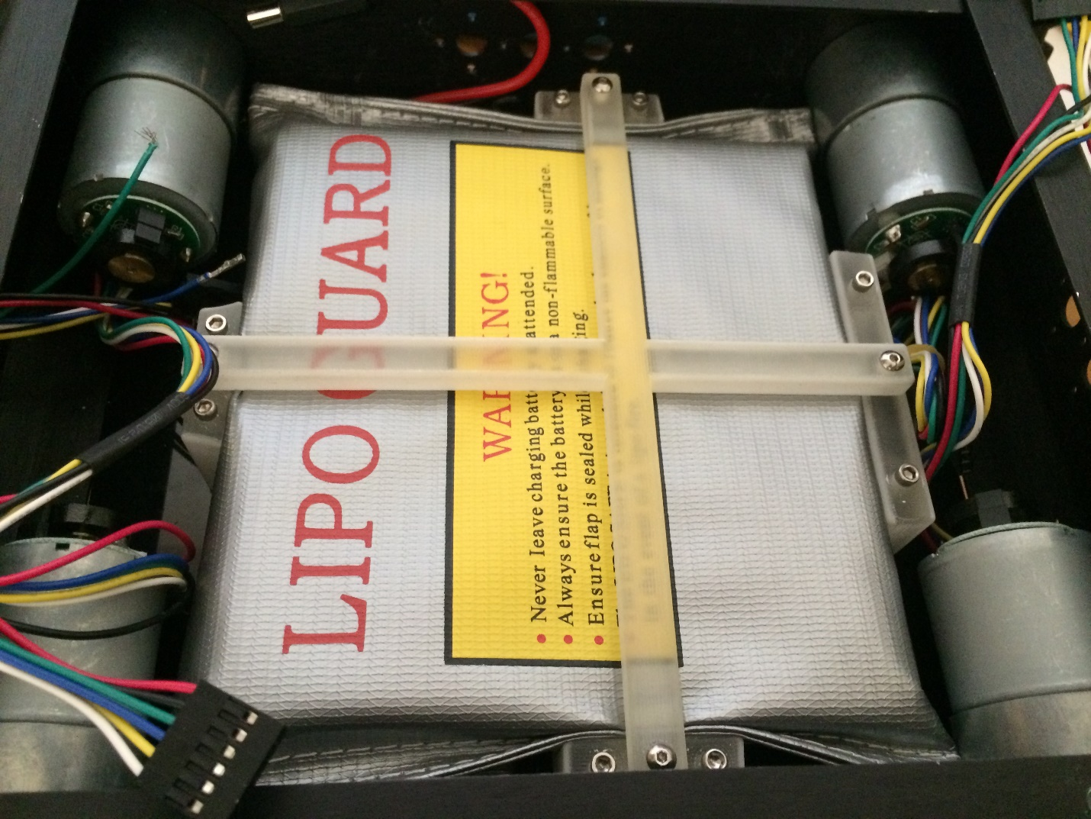

## Wheel Attachment

Tools:

* 5/32” hex key
* 3.5mm hex key

Parts:

* 2x mounting hub kit
* 4x assembled tires

The mounting hub kit will contain 2 mounting hubs, 2 larger wheel screws, and 3 set screws. 1 set screw is extra.

Begin by screwing the wheel screws into the mounting hubs. Then slide the mounting hubs onto the motor shafts and screw on the set screw. The wheel screws are screwed on first to ensure the mounting hub is attached at the correct distance from the motor.

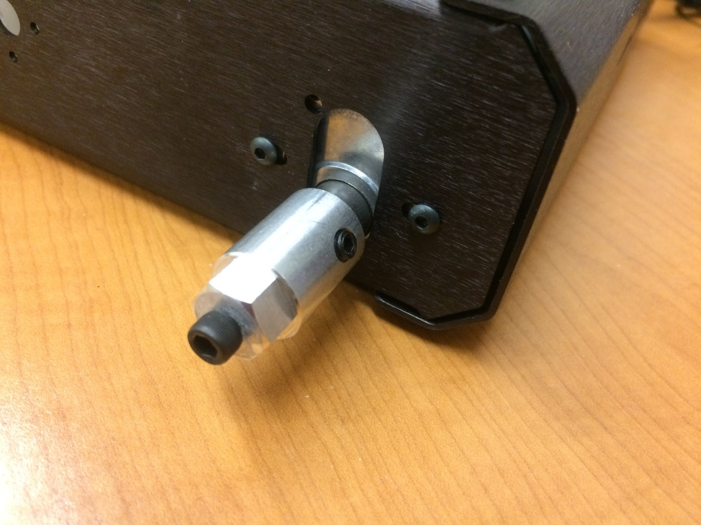

Unscrew the wheel screws, fit the wheel onto the mounting hub, and screw the wheel screw back in. In the picture below you can see the direction in which the tires should be pointed. The rear of the robot is considered to be the side of the larger battery base.

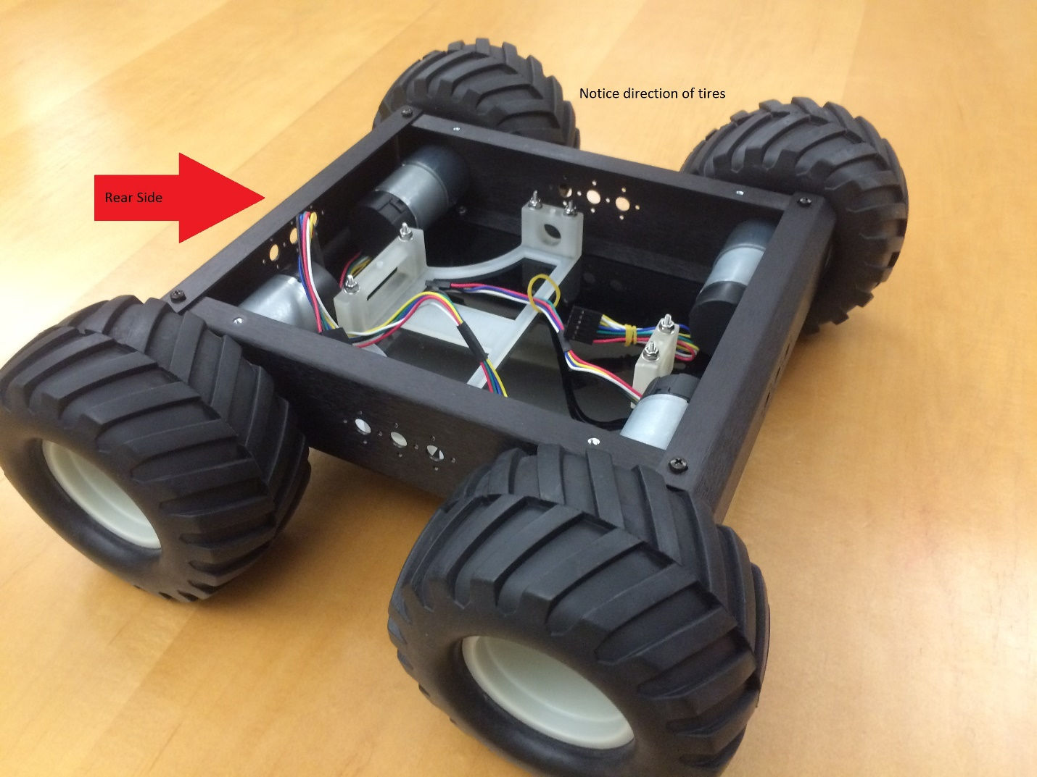

# Top Plate Assembly

The following is needed for constructing the top plate.

[Tools list]

[Parts list]

[This section includes instructions to attach all 3D printed parts to the top plate as well as electronics (ie. PCB, US, IMU, GPS, switch, buses, NUC, camera)]

[Waiting for newest version of the top plate]

## 3D Printed Parts

Below is a picture showing the orientation and placement of the 3D printed parts on the top plate. All of the parts (excluding the camera mount) attach to the top plate using 4-40x5/8” screws and 4-40 nyloc nuts. The NUC base will need only one washer per screw, the other parts will need two. Do not attach the camera mount or the NUC base until after the ultrasound mounts are attached.

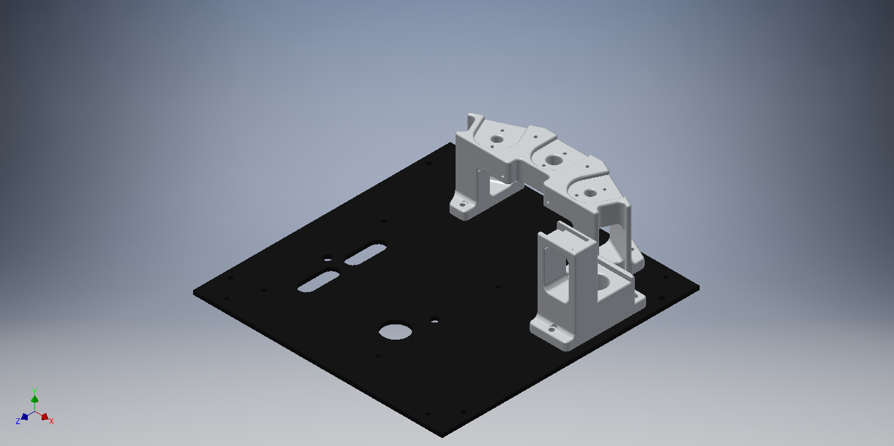

## Ultrasound Sensor Mounting

Tools:

* Phillips head screw driver
* 1/16” hex key

Parts:

* 6x 4-40x1/2” button head screws
* 3x ultrasound mount kits
* 3x ultrasound sensors

Remove the L-brackets from the ultrasound mount kits. In the picture below, the holes with screws in them need to be drilled out to fit 4-40 screws. A 1/8” drill bit was used for the holes pictured.

Attach the two plastic spacers from the kit using two of the four Philips head machine screws.

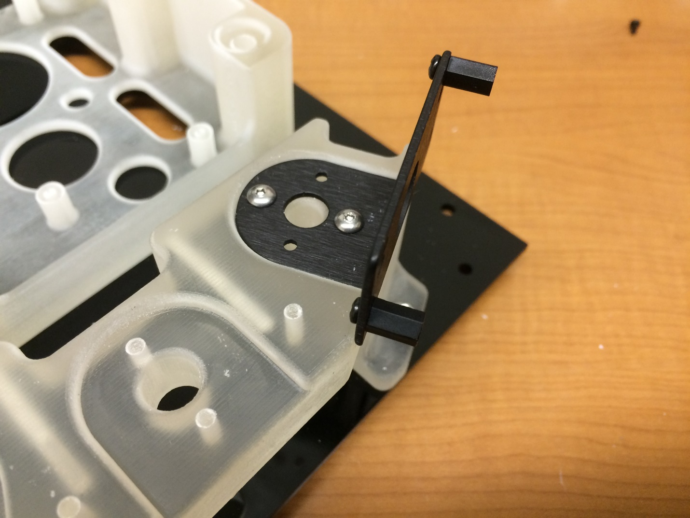

Using the other two Philips head machine screws, screw the ultrasound sensors to the plastic spacers. Below is a picture of a finished ultrasound.

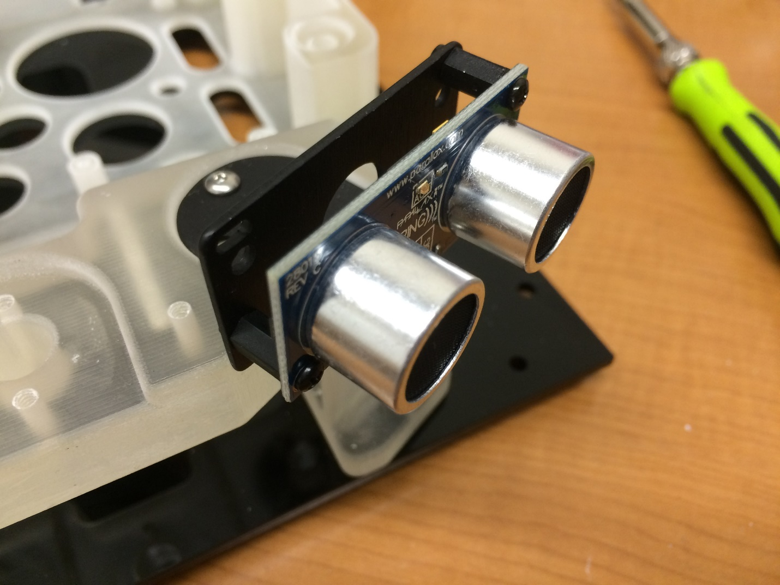

## NUC Base, Camera, IMU, GPS

Tools:

* Flat head screw driver

Parts:

* 1x 2-56x1/2” nylon screw
* 1x GPS
* 1x camera
* 1x IMU
* Double sided foam tape

Attach the camera mount to the ultrasound tower using four 4-40x1/2” button head screws.

Next, attach the NUC base to the top place using four 4-40x5/8” screws, four washers, and four nyloc nuts.

Use a strip of double sided foam tap to tape the GPS to the large flat part at the bottom of the GPS/IMU mount. Use the 2-56x1/2” nylon screw to attach the IMU to the top area on the GPS/IMU mount.

Use a strip of double sided foam tape to tape the camera to the top of the camera mount. At this point, the top plate should look like the picture below.

[Picture]

## PCB, Switch, and Bus Connections

[Great stuff]

## NUC Assembly

[M3x18mm]

## Cover Plate Assembly and Attachment

[Current version of the cover plate is in stock]

# Fully Assembled

[Include information about and pictures of the fully assembled Swarmie]